Event Manager Layer

Overview
The Event Manager Layer is to take in any input data acquired in the Data Acquisition Layer and determine what type of event has occurred, format the data, and forward it to the Processing Layer.

Assumptions
- Data sent from the Data Acquisition Layer is the only data that is to be handled (i.e. no other type of data will be handled)
- The data sent from the Data Acquisition Layer is to be in a format that can be analyzed to make decisions on the type of event that occurred.
- The data sent from the Data Acquisition Layer can be reformatted if necessary to allow the Processing Layer to fulfill its responsibilities.
- All features and functions must be performed in real-time

Responsibilities
The Event Manager Layer will be responsible for handling input data sent from the Data Acquisition Layer. The input data received by the Event Manager Layer represents a type of event. The Event Manager Layer will determine what type of event has occurred based on the input data received. Once a decision has been made, it will format the data in a form that is expected by the Processing Layer and forward the formatted data to that layer for processing.

Subsystems

User Event Manager

Description
The User Event Manager is a subsystem of the Event Manager Layer that has the same responsibilities as the layer that encompasses it, but focused on input data related to User Events.

Assumptions
- Data sent from the User Input subsystem is the only data that is to be handled (i.e. no other type of data will be handled)
- The data sent from the User Input subsystem is to be in a format that can be analyzed to make decisions on the type of event that occurred.
- The data sent from the User Input subsystem can be reformatted if necessary to allow the subsystems of the Processing Layer (described later) to fulfill their responsibilities.
- All features and functions must be performed in real-time

Responsibilities
The User Event Manager will be responsible for handling input data sent from the User Input subsystem of the Data Acquisition Layer. The input data received by the User Event Manager represents a type of User Event. The User Event Manager Layer will determine what type of User Event has occurred based on the input data received. Once a decision has been made, it will format the data in a form that is expected by the subsystems of the Processing Layer and forward the formatted data to those subsystems for processing.

Subsystem Inter-layer Interfaces
Will need picture here
Table 1.1. Public Interface to Definition Management Layer.
Method | Description | Information  Required | InformationReturned
getUserInput | Reads in any User Input Data and returns the data read for determining type of User Event | none | User Input Data
sendOnOffData | Sends the formatted On/Off Data to the Processing Layer | formatted On/Off Data | none
sendDetectionRangeData | Sends the formatted Detection Range Data to the Processing Layer | formatted Detection Range Data | none

Subsystem Public Interfaces
This subsystem does not interact directly with the external world.

Detection Event Manager

Description
The Detection Event Manager is a subsystem of the Event Manager Layer that has the same responsibilities as the layer that encompasses it, but focused on input data related to Object Detection Events.

Assumptions
- Data sent from the Distance Sensor Input subsystem is the only data that is to be handled (i.e. no other type of data will be handled)
- The data sent from the Distance Sensor Input subsystem is to be in a format that can be analyzed to make decisions on the type of event that occurred.
- The data sent from the Distance Sensor Input subsystem can be reformatted if necessary to allow the Logical subsystem of the Processing Layer to fulfill its responsibilities.
- All features and functions must be performed in real-time

Responsibilities
The Detection Event Manager will be responsible for handling input data sent from the Distance Sensor Input subsystem of the Data Acquisition Layer. The input data received by the Detection Event Manager represents a type of Object Detection Event. The Detection Event Manager will determine what type of Object Detection Event has occurred based on the input data received. Once a decision has been made, it will format the data in a form that is expected by the Logical subsystem of the Processing Layer and forward the formatted data to that subsystem for processing.

Subsystem Inter-layer Interfaces
Will need picture here
Table 1.2. Public Interface to Definition Management Layer.
Method | Description | Information  Required | InformationReturned
getDistanceSensorInput | Reads in any Distance Sensor Input Data and returns the data read for determining type of Object Detection Event | none | Distance Data
sendDistanceData | Sends the formatted Distance Data to the Processing Layer | formatted Distance Data | none

Subsystem Public Interfaces
This subsystem does not interact directly with the external world.

Low Battery Event Manager

Description
The Low Battery Event Manager is a subsystem of the Event Manager Layer that has the same responsibilities as the layer that encompasses it, but focused on input data related to Low Battery Events.

Assumptions
- Data sent from the Battery Sensor Input subsystem is the only data that is to be handled (i.e. no other type of data will be handled)
- The data sent from the Battery Sensor Input subsystem is to be in a format that can be analyzed to make decisions on the type of event that occurred.
- The data sent from the Battery Sensor Input subsystem can be reformatted if necessary to allow the Logical subsystem of the Processing Layer to fulfill its responsibilities.
- All features and functions must be performed in real-time

Responsibilities
The Low Battery Event Manager will be responsible for handling input data sent from the Battery Sensor Input subsystem of the Data Acquisition Layer. The input data received by the Low Battery Event Manager represents a type of Low Battery Event. The Low Battery Event Manager will determine what type of Low Battery Event has occurred based on the input data received. Once a decision has been made, it will format the data in a form that is expected by the Logical subsystem of the Processing Layer and forward the formatted data to that subsystem for processing.

Subsystem Inter-layer Interfaces
Will need picture here
Table 1.3. Public Interface to Definition Management Layer.
Method | Description | Information  Required | InformationReturned
getBatterySensorInput | Reads in any Battery Sensor Input Data and returns the data read for determining type of Low Battery Event | none | Low Battery Data
sendLowBatteryData | Sends the formatted Low Battery Data to the Processing Layer | formatted Low Battery Data | none

Subsystem Public Interfaces
This subsystem does not interact directly with the external world.

Processing Layer

Overview
The Processing Layer is to take in any formatted data sent from the Event Manager Layer and make decisions based on the formatted data sent to send specific signals to the Notification Layer.

Assumptions
- Data sent from the Event Manager Layer is the only data that is to be handled (i.e. no other type of data will be handled)
- The data sent from the Event Manager Layer is to be in a format that can be analyzed to make decisions on the specific signal to send to the Notification Layer.
- All features and functions must be performed in real-time

Responsibilities
The Processing Layer will be responsible for making decisions on what type of signal to send to the Notification Layer based on the formatted data sent by the Event Manager Layer. The formatted data received by the Processing Layer will be processed to determine the specific signal needed to send to the Notification Layer. Once a decision has been made, it will send the signal determined to the Notification Layer in an expected format.

Subsystems

On/Off

Description
On/Off is a subsystem of the Processing Layer that has the same responsibilities as the layer that encompasses it, but focused on formatted data related to On/Off User Events.

Assumptions
- Data sent from the User Event Manager subsystem is the only data that is to be handled (i.e. no other type of data will be handled)
- The data sent from the User Event Manager subsystem is to be in a format that can be analyzed to make decisions on the type of signal to send to the On/Off Notification subsystem of the Notification Layer (described later).
- All features and functions must be performed in real-time

Responsibilities
On/Off will be responsible for making decisions based on the formatted On/Off Data sent from the User Event Manager subsystem of the Event Manager Layer. The formatted On/Off Data sent by the User Event Manager will be processed to determine the type of signal to send to the On/Off Notification subsystem. Once a decision has been made, it will send the signal determined to the On/Off Notification subsystem.

Subsystem Inter-layer Interfaces
Will need picture here
Table 1.4. Public Interface to Definition Management Layer.
Method | Description | Information  Required | InformationReturned
getOnOffInput | Reads in any On/Off Data and returns the data read for determining type of signal for On/Off event | none | On/Off Data
sendOnOffNotification | Sends the On/Off signal determined to the Notification Layer | On/Off signal | none

Subsystem Public Interfaces
This subsystem does not interact directly with the external world.

Logical

Description
Logical is a subsystem of the Processing Layer that focuses on making decisions based on the formatted data sent by the subsystems of the Event Manager Layer.

Assumptions
- Data sent from the Event Manager Layer subsystems are the only data that is to be handled (i.e. no other type of data will be handled)
- The data sent from the Event Manager Layer subsystems are to be in a format that can be analyzed to make decisions on the type of signal to send to the Object Notification and Battery Notification subsystems of the Notification Layer (described later).
- All features and functions must be performed in real-time

Responsibilities
Logical will be responsible for making decisions based on the formatted data sent from the Event Manager Layer subsystems. The formatted data sent by the Event Manager Layer subsystems will be processed to determine the types of signals to send to the Object Notification and Battery Notification subsystems. Once a decision has been made, it will send the signals to the Object Notification and Battery Notification subsystems.

Subsystem Inter-layer Interfaces
Will need picture here
Table 1.5. Public Interface to Definition Management Layer.
Method | Description | Information  Required | InformationReturned
getUserData | Reads in any formatted data from the User Event Manager subsystem and returns the data read for determining type of signal to send to the Object Notification subsystem?????? | none | formatted User Event Data
getDistanceData | Reads in any formatted data from the Detection Event Manager subsystem and returns the data read for determining type of signal to send to the Object Notification subsystem | none | formatted Distance Data
getLowBatteryData | Reads in any formatted data from the Low Battery Event Manager subsystem and returns the data read for determining type of signal to send to the Low Battery Notification subsystem | none | formatted Low Battery Data
sendIntensitySignal | Sends an Vibration Intensity Signal to the Object Notification subsystem | Vibration Intensity Signal | none
sendLowBatterySignal | Sends a Low Battery Signal to the Low Battery Notification subsystem | Low Battery Signal | none

Subsystem Public Interfaces
This subsystem does not interact directly with the external world.

Inter-Subsystem Data Flow Section
This section details the data flow between each subsytem in the layered architecture of the Sight By Touch system.
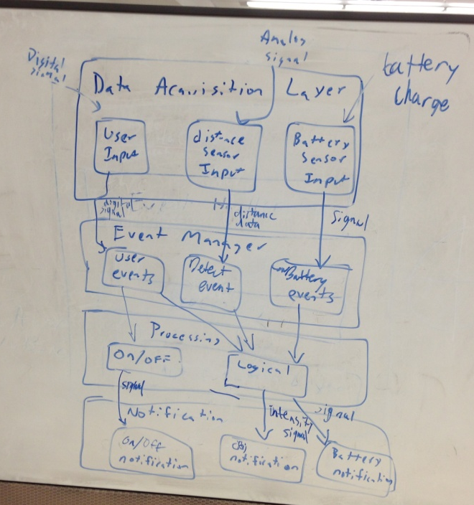
1
2
3
4
5
6
7
8
9
10
11
12
13
Figure 1.1. Architectural Data flow Diagram.
The following table will describe the data flows between subsystems in tabular form.
Table 1.6. Sample Inter-Subsystem Data Element Descriptions.
Data Element |  | Descriptions
1. Input from user | The data from the system control module regarding user input as a digital signal
2. Input from the distance sensors | The data from the distance sensors regarding object detection as an analog signal
3. Input from battery sensor | The data from the battery sensor regarding the charge of the battery as an analog signal
4. User Input signal | The digital signal sent by the User Input subsystem to the User Event Manager subsystem to determine type of User Event
5. Distance Data | The distance information derived by the Distance Sensor Input subsystem to determine the type of Object Detection Event
6. Low Battery Signal | The signal sent by the Battery Sensor Input subsystem that will determine the type of Low Battery Event
7. On/Off Signal | The digital signal sent by User Event subsystem to the On/Off subsystem to process the type of notification to send to the On/Off Notification subsystem
8. Range Data | Data that will be used by the Logical subsystem to determine whether the Object detected is within the range specified by the user in order to decide to notify the user or not
9. Object Detection Data | Data that will be used by the Logical subsystem to process the type of notification to send to the Object Notification subsystem
10. Low Battery Data | Data that will be used by the Logical subsystem to process the type of notification to send to the Low Battery Notification subsystem
11. On/Off Notification Signal | The signal that will be sent to the On/Off Notification subsystem to tell the subsystem exactly what notification to use to notify the user that the system has been turned on/off
12. Intensity Signal | The signal that will be sent to the Object Notification subsystem to tell the subsystem exactly what notification to use to notify the user that the system has detected an object at a particular range
13. Low Battery Signal | The signal that will be sent to the Low Battery Notification subsystem to tell the subsystem exactly what notification to use to notify the user how much charge the battery has left to power the system
The following table documents the actual data flow paths of the data elements between subsystems in the form of a Producer-Consumer matrix.
Table 1.7. Producer-Consumer Relationships.
 | Consumer Subsystem
Producer  Subsystem | User Event Manager | Detection Event Manager | Low Battery Event Manager | On/Off | Logical | On/Off Notification | Object Notification | Low Battery Notification
User Input | 4.
Distance Sensor Input |  | 5.
Battery Sensor Input |  |  | 6.
User Event Manager |  |  |  | 7. | 8.
Detection Event Manager |  |  |  |  | 9.
Low Battery Event Manager |  |  |  |  | 10.
On/Off |  |  |  |  |  | 11.
Logical |  |  |  |  |  |  | 12. | 13.

Operating System Dependencies Section

Data Acquisition Layer
The Data Acquisition Layer is dependent on the type of user interface, distance sensors, and battery measuring mechanism used.

Event Manager Layer
The Event Manager Layer will be developed in the C programming language on a microcontroller. It will be dependent on the type of microcontroller and associated libraries used.

Processing Layer
The Processing Layer will be developed in the C programming language on a microcontroller. It will be dependent on the type of microcontroller and associated libraries used.

Notification Layer
The Notification Layer will be dependent on the types of vibration motors used to notify the user.

